THE HISTORY OF EVOLUTIONARY THEORY

Darwinian Evolution
Darwin was not the first person to explain the process of evolution. Many had done so before him. Darwin’s unique contribution was that he proposed a systematic mechanism for evolution – a set of rules by which evolution occured.
His famous book was called On the Origin of Species by Means of Natural Selection. Darwin provided detailed evidence to support his ideas – much of which came from his collections from the Galapagos Islands. The book is therefore quite complex. This is surprising because the things Darwin was saying were very simple. His main ideas were:
- Living things tend to produce too many offspring.
They produce more offspring than could possibly survive. Only a small percentage of the offspring survive because resources such as food, shelters, mates etc. are limited.
- These offspring will not be identical.
The offspring will vary, even if only slightly. Nowadays, we know this is due to random mutations or combinations of genes due to sexual reproduction. You are different to your parents and siblings.
- Some of the variations (traits) in the offspring will allow them to be better adapted to their environment.
Some offspring are better able to find food, shelters, and mates. These offspring are the “fittest” and are more likely to survive in greater numbers and produce the next generation of offspring.
- Variation (traits) in organisms is inherited.
The offspring of the ‘fittest’ and most successful organisms will inherit the new successful trait
- Eventually, a population will be made up mainly of individuals with the new trait
The species has adapted to be more successful in their environment. Evolution has occurred.
Natural Selection is the term used by scientists to describe Darwin’s theory.
Describe how Scientists would use Darwin’s’ theory of natural Selection (outlined above) to explain the following observations.
  - In some species of birds, the parent birds do not give food to each chick (baby bird). The chicks have to fight for the food brought back to the nest by the parents.

  - In the 1970s, on the Galápagos Islands, a drought occurred. As a result, fewer seeds were available for finches to eat. Birds with smaller beaks could crack open and eat only the smaller seeds. Birds with bigger beaks could crack and eat seeds of all sizes. As a result, many of the small-beaked birds died in the drought. Birds with bigger beaks survived and reproduced. Within 2 years, the average beak size in the finch population increased.

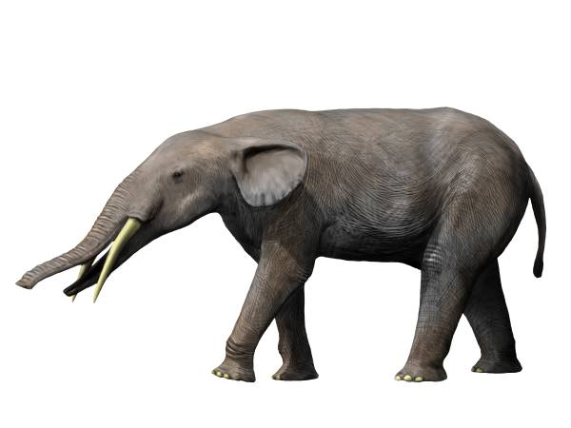
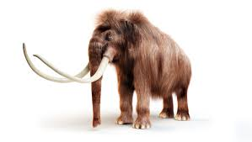
  - African elephants, Asian elephants, and Mammoths (now extinct), all had a common ancestor – Gomphotherium. A brief description of each is given below.
Gomphotherium – were approximately 2.5 metres tall, and had four relatively short tusks. Their natural habitat ranged from swamps to forests. Their diet was plant based. Ancestor of the modern elephant – lived from 5 million year age to 2 millions years ago
African elephant – are about 3.5 metres tall, have two long tusks, and large ears. Their natural habitat is open grasslands in Africa.
Asian elephant – are about 2.5 metres tall, males have two small tusks, and small ears. Their natural habitat is dense forests and jungle.
Woolly Mammoth – were approximately 4 metres tall, had two very long tusks, and very small ears. They were covered with wool. Their natural habitat was tundra (cold but well vegetated grasslands). They had a bulge of stored fat on their back. They are now extinct (~10000 yrs ago).

Use Darwin’s theory of evolution to explain how each of the three types of modern elephant may have evolved from Gomphotherium.

